Resetting a Password in Workday

1. Go to the **Related Actions** off the worker

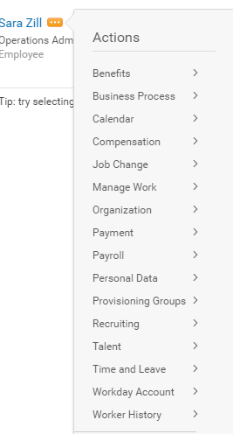

1. Hover over **Security Profile** and select **Edit Workday Account**

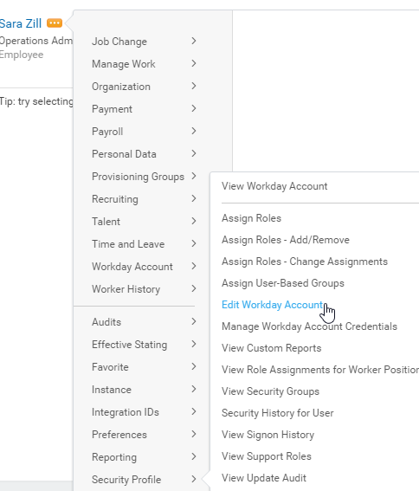

1. Check the box for **Require New Password at Next Sign In**

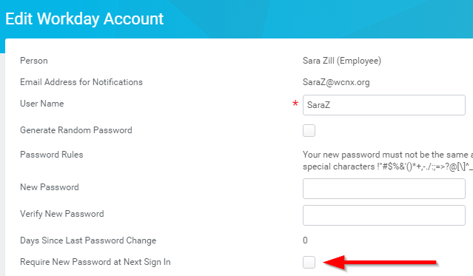

1. Hit **Submit**

